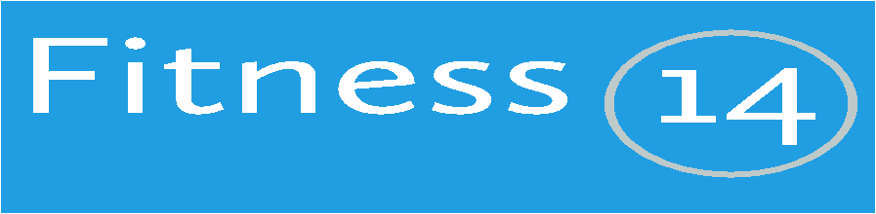

CMC Sports & Social Club
University Hospital of Wales, Heath Park, CF14 4XW

New Timetable from May 2022
Classes can be booked and paid for 48 hours ahead
All bookings are non-refundable and non-transferrable
Monday | Class |  | Instructor*  *Subject to change | Time
5pm | Spin |  | Sian | 45mins
Tuesday | Class |  | Instructor | Time
5pm | Yoga Balance |  | Gemma | 55mins
Wednesday | Class |  | Instructor | Time
5pm | Spin |  | Sian | 45 mins
7pm | Weight Circuits |  | Mark | 60 mins
Thursday | Class |  | Instructor | Time
5pm | Yoga Balance |  | Gemma | 55 mins
CHARGE PER CLASS Member Guest

£4.25 £6.85

For further information call (029) 207-42440 or
email info@cmcsportsandsocialclub.co.uk

Suitable for all levels of fitness
oParty yourself into shape!!

